Farmer’s Market Nutrition Program
Biennial Report

2013 & 2014

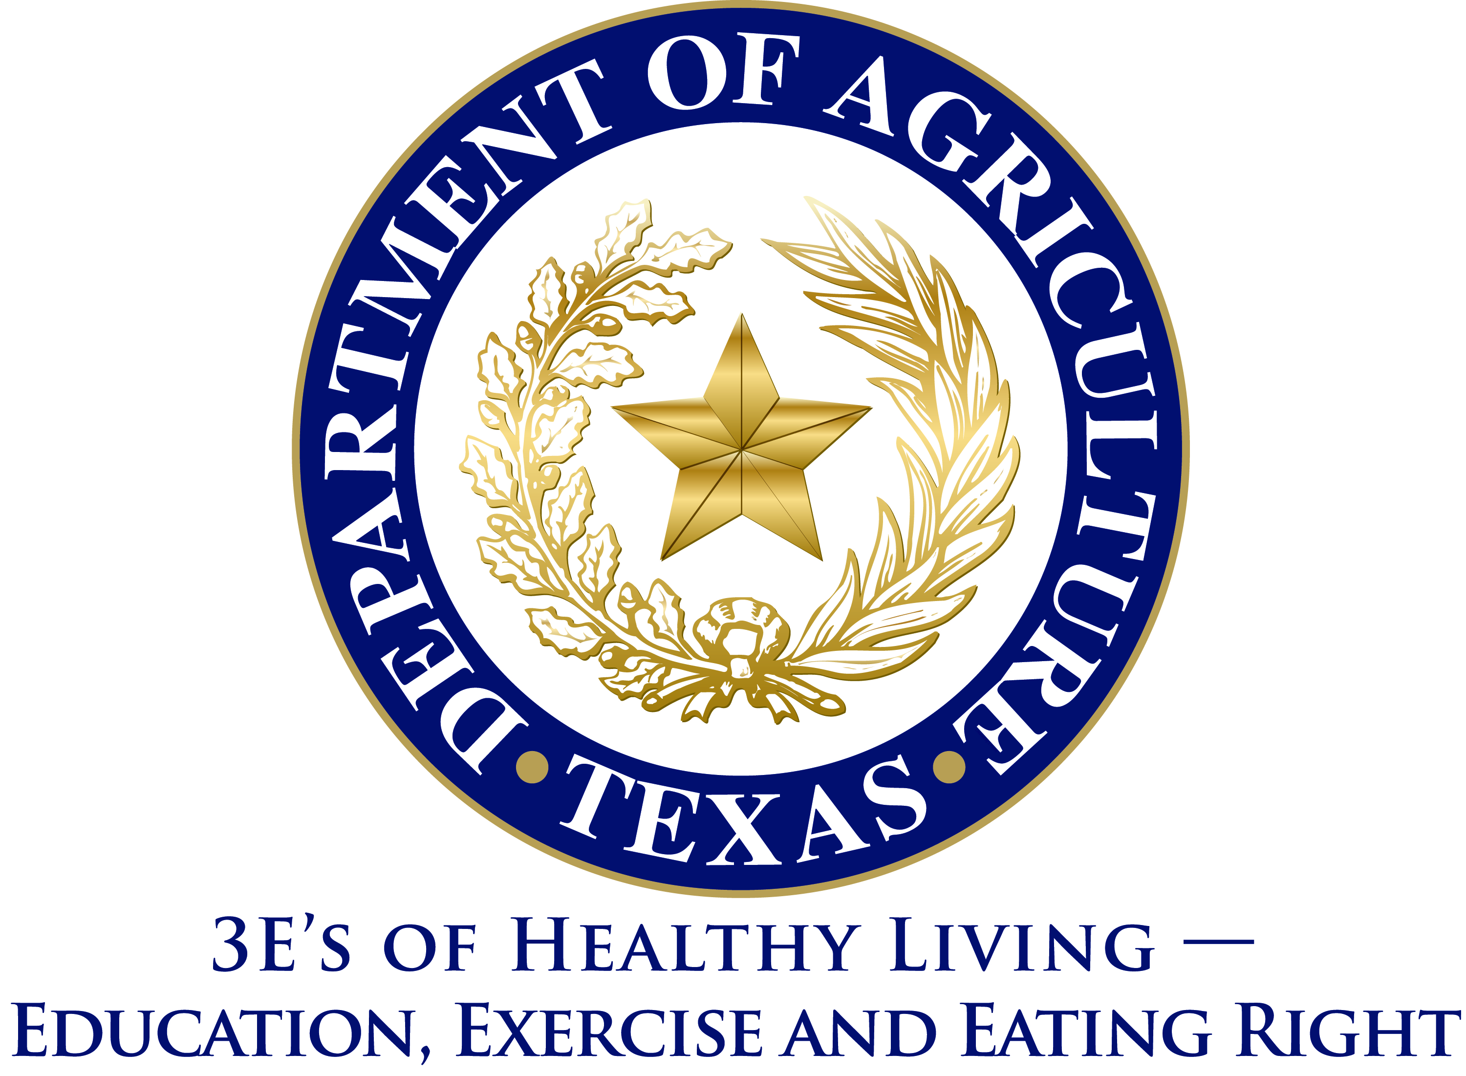
Contents

Executive Summary 3
Charge 5
2013 & 2014 Federal Fiscal Year Summary 6

Executive Summary

In 2013, the 83rd Legislative session passed SB 59, requiring the Farmers Market Nutrition Program report to be submitted biennially, instead of annually. This document reflects the first biennial submission of this report.
In March 2012, the Texas Department of Agriculture (TDA) assumed administration of the Farmer’s Market Nutrition Program (FMNP) from the Department of State Health Services (DSHS). DSHS previously administered the program under the name WIC FMNP. Due to state budget cuts at DSHS that eliminated the agency’s ability to fund the state match for the program, DSHS chose to no longer administer the program. TDA developed and implemented a plan for continuing the program with no state funds and took over the program to avoid program elimination. TDA currently operates the program using federal funds and state in-kind contributions.

To accomplish program continuation without state funding dedicated to the federally-required match, TDA developed a partnership with food banks, private non-profits, and governmental entities to administer the program in their respective areas. Their administrative costs satisfy state match requirements. Rather than distributing vouchers through WIC clinics, as was previously the case, the vouchers are administered by food banks, private non-profits, and governmental entities to their clientele who meet WIC eligibility requirements. This has increased the voucher utilization percentages as TDA has seen continuous improvement in voucher issuance percentages since administering the program in 2012.

The Farmer’s Market Nutrition Program allows qualified participants to buy nutritious fresh fruits and vegetables using FMNP vouchers from participating farmers’ market associations to improve their diets. FMNP:
- Operates in eight metropolitan areas to maximize limited resources;
- Provides resources to low-income women and children in the form of fresh, nutritious, unprepared, locally grown fruits, vegetables, and culinary herbs from farmers' markets in Texas
- Increases the domestic consumption of agricultural commodities by helping develop or expand domestic farmers' markets.

TDA has implemented several strategies to increase voucher distribution and continues to focus on enhancing efficiency of program operation. In 2014, the farmer’s market program period was extended to 10 months (February-November) and facilitated the sharing of best practices between food banks, private non-profits, and governmental entities to ensure appropriate focus was provided on voucher distribution methods. The number of farmer market areas was also expanded to 8 areas. Market areas participating in the program in 2014 included: Austin, Houston, Fort Worth, Lubbock, San Antonio, Tyler, Wichita Falls, and Pharr.

In federal fiscal year 2013 and 2014 (October 1, 2012-September 30, 2013 and October 1, 2013-September 30, 2014) vouchers were distributed to qualified participants in partnership with Texas area food banks, private non-profits, and governmental entities. A decreased number of participants were served in 2014 compared to 2013; however, participants redeemed $596,292 in vouchers in 2014, up 36% from $438,156 in 2013.

Charge

Agriculture Code, Title 2. Department Of Agriculture, Chapter 15. Farmers Market Nutrition Programs, Subchapter A
Sec. 15.006. BIENNIAL REPORT. The department shall prepare a biennial report concerning the special nutrition program and submit a copy of the report to the governor, lieutenant governor, and speaker of the house of representatives. The report must include information on the condition of the program, persons served, amount of food coupons redeemed, and funds received and expended.

2013 & 2014 Federal Fiscal Year Summary

Farmer’s Market Nutrition Program
2013 Summary
Funds Received | $1,022,093.00
Funds Expended | $611,911.81
Amount of Coupons Redeemed | $438,156.00
Number of Participants Served | 21,908

Farmer’s Market Nutrition Program
2014 Summary
Funds Received | $1,054,646.00
Funds Expended | $775,581.82
Amount of Coupons Redeemed | $596,292
Number of Participants Served | 19,876

