Health Department Tool
Instruction Guide
Once a CE has chosen its prospective SFSP sites, the CE must notify the appropriate local health department(s) in writing of all prospective summer site locations. The Health Inspector Locator Tool helps the CE identify the contact information of the appropriate health department(s) for their SFSP site operation(s).
Guide to using tool:
Step one: Enter zip code of site
Note: Depending on the site zip code, the health department jurisdiction may vary.
Step Two: Reading the Tool
Select the contact information for the health department based on the following priorities:
- Local
- Regional
- State
Example:
Enter Zip Code of 78701, Contacting Entity would contact Austin Public Health to learn more about the specific requirements for Food Establishments.
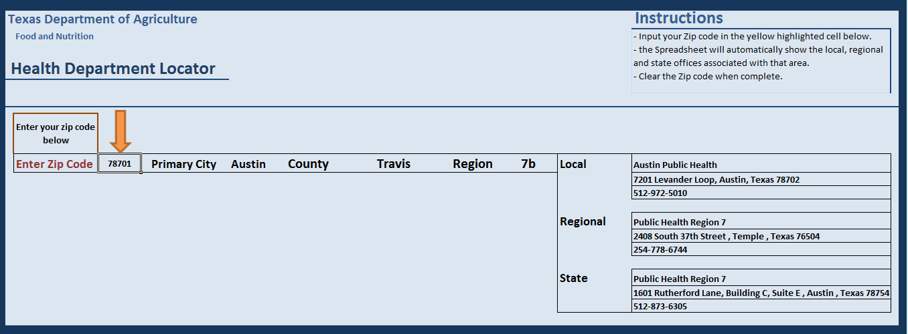
Example:
Enter Zip Code of 78643, Contacting Entity would contact the Regional Office to learn more about the specific requirements for Food Establishments.
